**Notes on Sentiment Analysis**

**Khurshid Ahmad, Trinity College Dublin, Dublin, IRELAND**

**21 Oct 2018**

Contents

Basics 2

Price Changes in Financial Markets 2

Efficient Market Hypothesis 2

Price Discovery: 2

Mean reversion 2

Noise 3

Moments: 5

Returns: 5

Stylised Facts for financial returns. 5

Boeing Stock 1983-2013 7

Technical Analysis: Bollinger Bonds 7

Boeing Price and Return Movements 8

SENTIMENT 11

EMH and Sentiment 12

Types of Sentiment: 12

Market Sentiment: 13

Consumer Sentiment: 13

Yale Confidence Indices 13

Developments in Sentiment Based Decision Making 16

Role of Arbitrage 16

Market Movements and Sentiment 17

News Flow 18

# Basics

## Price Changes in Financial Markets

### Efficient Market Hypothesis

An investment theory that states it is impossible to "beat the market" because stock market efficiency causes existing share prices to always incorporate and reflect all relevant information. According to the EMH, stocks always trade at their fair value on stock exchanges, making it impossible for investors to either purchase undervalued stocks or sell stocks for inflated prices. As such, it should be impossible to outperform the overall market through expert stock selection or market timing, and that the only way an investor can possibly obtain higher returns is by purchasing riskier investments.

<http://www.investopedia.com/terms/e/efficientmarkethypothesis.asp>

### Price Discovery:

A method of determining the price for a specific commodity or security through basic supply and demand factors related to the market.

<http://www.investopedia.com/terms/p/pricediscovery.asp>

### Mean reversion

A theory suggesting that prices and returns eventually move back towards the mean or average. This mean or average can be the historical average of the price or return or another relevant average such as the growth in the economy or the average return of an industry.

<http://www.investopedia.com/terms/m/meanreversion.asp>

### Noise

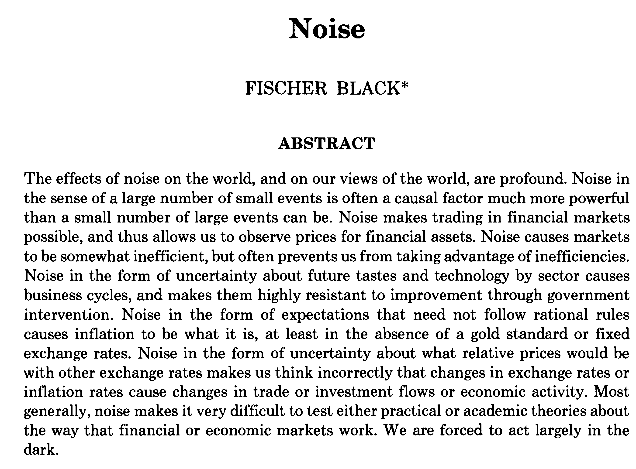

**Black, Fischer. (1986). Noise. *Journal of Finance*. Vol 41 (No.3). 529-541**

Noise has many forms:

Noise is caused by a projection of future tastes and technology by sector causes business cycles; these cycles cannot be controlled by interventions (statal or corporate);

Noise is about irrational expectations about fiscal and monetary systems and are largely immune to remedies (statal or corporate);

Herding:

Assume that there are two kinds of traders only in a market: informed traders and noise traders. The noise trader fails to ascertain the true value of an asset and relies on guesswork, heuristics, imitation of the informed trader, or prayer. The noise trader *misprices* and the informed trader should see this as an opportunity to create a margin through arbitrage. This arbitrage is not always possible and worse still the informed tries to follow the noise trader.

Informed Trader Wins: BOOM 🡪 BUST 🡪 BOOM🡪 BUST

Noise Trader Wins: BOOM🡪 BOOM 🡪 BOOM🡪 **BUST**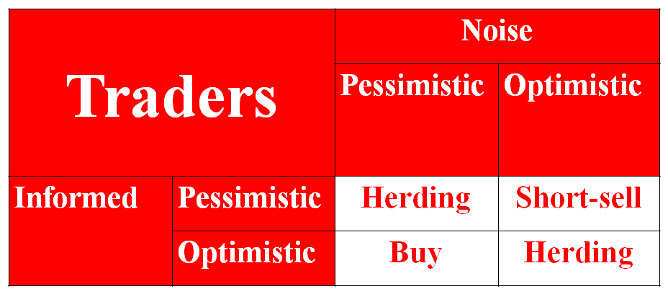

## Moments:

In [mathematics](http://en.wikipedia.org/wiki/Mathematics), a **moment** is, loosely speaking, a quantitative measure of the shape of a set of points. The "second moment", or more specifically the "second [central moment](http://en.wikipedia.org/wiki/Central_moment)", for example, is widely used and measures the "width" (in a particular sense) of a set of points in one dimension, or in higher dimensions measures the shape of a cloud of points as it could be fit by an [ellipsoid](http://en.wikipedia.org/wiki/Ellipsoid). Other moments describe other aspects of a [distribution](http://en.wikipedia.org/wiki/Distribution_%28mathematics%29) such as how the distribution is skewed from its mean. The mathematical concept is closely related to the concept of [moment](http://en.wikipedia.org/wiki/Moment_%28physics%29) in [physics](http://en.wikipedia.org/wiki/Physics), although moment in physics is [often represented somewhat differently](http://en.wikipedia.org/wiki/Moment_of_inertia#Comparison_with_covariance_matrix).[[*dead link*](http://en.wikipedia.org/wiki/Wikipedia:Link_rot)] Any distribution can be characterized by a number of features (such as the [mean](http://en.wikipedia.org/wiki/Mean), the [variance](http://en.wikipedia.org/wiki/Variance), the [skewness](http://en.wikipedia.org/wiki/Skewness), etc.), and the moments of a random variable's [probability distribution](http://en.wikipedia.org/wiki/Probability_distribution) are related to these features. The probability distribution itself can be expressed as a [probability density function](http://en.wikipedia.org/wiki/Probability_density_function), [probability mass function](http://en.wikipedia.org/wiki/Probability_mass_function), [cumulative distribution function](http://en.wikipedia.org/wiki/Cumulative_distribution_function), [characteristic function](http://en.wikipedia.org/wiki/Characteristic_function_%28probability%29), or [moment-generating function](http://en.wikipedia.org/wiki/Moment-generating_function).

## Returns:

Statistical analysis of market prices is more difficult than analysis of changes in prices. This is because consecutive prices are highly correlated but consecutive changes have very little correlation, if any. Consequently, it is more convenient to investigate suitable measures of changes in prices. (Taylor 2005:14-15)

Let the price of a financial instrument or commodity be pt at time, and suppose that dt is the dividend to be distributed to the holders of the instrument or commodity, so the return on investing between time t and t-1 will be the difference between prices pt and pt-1 and the dividend or profit dt. Three forms of returns are discussed in the literature (Taylor 2005:16)

First difference: 

One period return 

Continuously compounded return 

## Stylised Facts for financial returns.

Three important properties that are found in almost all sets of daily returns obtained from the prices of stocks, bonds, commodities, stock market indices and exchange rates amongst others.

1. Distribution of returns is not normal

2. There is almost no correlation between returns for different days.

3. The correlations between the magnitudes of returns on nearby days are poisitive and statistically significant.

Taylor argues that ‘these properties can all be explained by changes through time in volatility’ (ibid:51) 🡪 volatility is a measure of price variability over some period of time, and one model used for calculating volatility is the use of the second moment like standard deviation:

Realised Volatility: Unconditional standard deviation (*s*) of daily returns – without any information about the history of previous *N-1* returns



Conditional Volatility: Standard deviation (*ht*) of a future return that is conditional on known information such as the history of previous returns:



The parameters    and  are estimated from a long time series of returns.

## Boeing Stock 1983-2013

### Technical Analysis: Bollinger Bonds

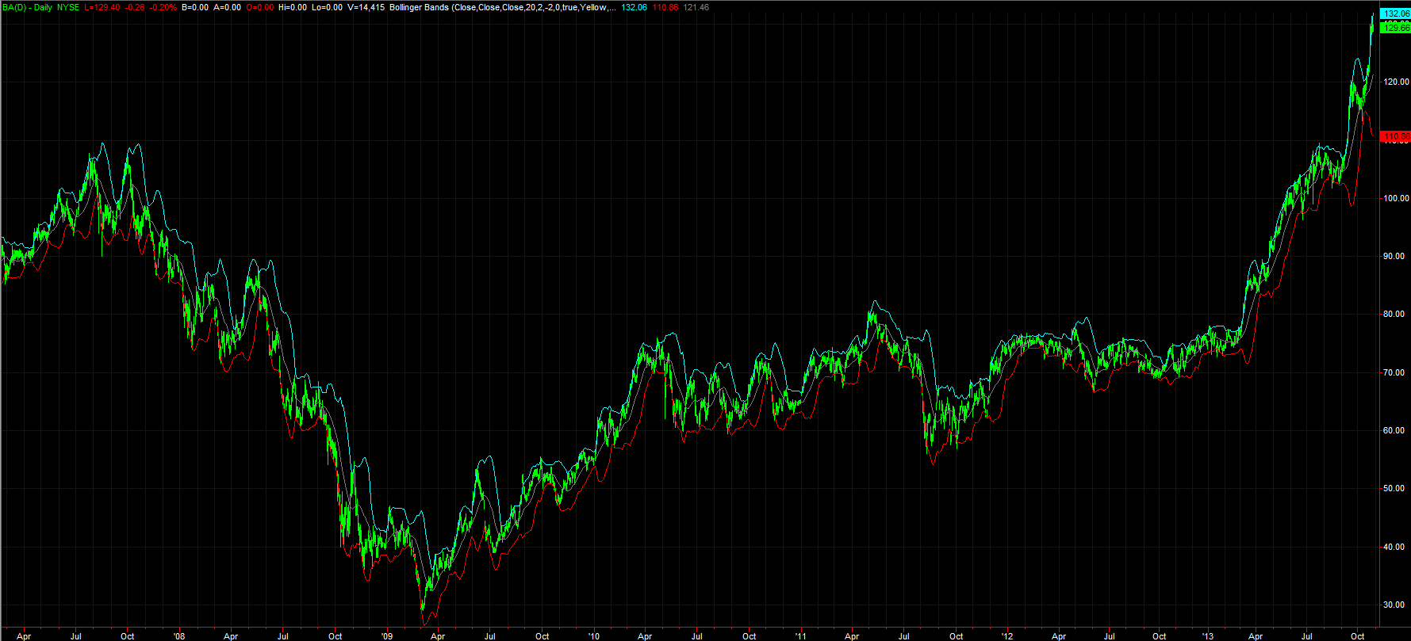

### Boeing Price and Return Movements

Traded Volume of Boeing Shares

Persistence in Returns

Persistence of Negative and Positive Returns

Moving Averages and Changes in Stylised Facts

**Unconditional standard deviation**

**Unconditional average return**

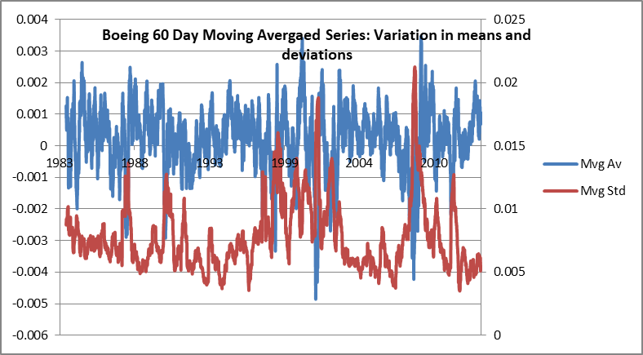

# SENTIMENT

What one feels with regard to something; mental attitude (of approval or disapproval, etc.); an opinion or view as to what is right or agreeable. Often pl. with collective sense.

A mental feeling, an emotion. Now chiefly applied, and by psychologists sometimes restricted, to those feelings which involve an intellectual element or are concerned with ideal objects.

Refined and tender emotion; exercise or manifestation of ‘sensibility’; emotional reflection or meditation; appeal to the tender emotions in literature or art. Now chiefly in derisive use, conveying an imputation of either insincerity or mawkishness.

<http://www.oed.com/view/Entry/176056?redirectedFrom=sentiment#eid>

RATIONAL

Having the faculty of reasoning; endowed with reason. Esp. in rational being, rational creature, rational soul

That uses, or is capable of using, the faculty of reasoning; having sound judgement; (in extended use) sensible, sane, lucid. Also: characterized by reasoning, as opposed to emotion, intuition,

Chiefly Econ. Involving or characterized by any of various methods of analysis or planning based on the calculation of a projected result; designating such a method.

rational philosophy n. [after classical Latin philosophia ratiōnālis] a form of philosophy which emphasizes the role or significance of reason, esp. as opposed to sense experience: sometimes contrasted with moral and natural philosophy

<http://www.oed.com/view/Entry/158502?rskey=qhT74a&result=3&isAdvanced=false#eid>

## EMH and Sentiment

## Types of Sentiment:



[http://www.pionline.com/article/20131028/PRINTSUB/310289999/market-efficiencys-challenge#](http://www.pionline.com/article/20131028/PRINTSUB/310289999/market-efficiencys-challenge)

### Market Sentiment:

The overall attitude of investors toward a particular security or larger financial market. Market sentiment is the feeling or tone of a market, or its crowd psychology, as revealed through the activity and price movement of the securities traded in that market. For example, rising prices would indicate a bullish market sentiment, while falling prices would indicate a bearish market sentiment. Market sentiment is also called "investor sentiment" and is not always based on fundamentals.

<http://www.investopedia.com/terms/m/marketsentiment.asp>

### Consumer Sentiment:

A statistical measurement and economic indicator of the overall health of the economy as determined by consumer opinion. Consumer sentiment takes into account an individual's feelings toward his or her own current financial health, the health of the economy in the short term and the prospects for longer term economic growth.

<http://www.investopedia.com/terms/c/consumer-sentiment.asp>

### Yale Confidence Indices

Robert J Shiller started a survey of institutional and individual investor confidence in stock markets on a six monthly basis in 1989 and then the frequency increased to monthly surveys in 2001.



The Sveriges Riksbank Prize in Economic Sciences in Memory of Alfred Nobel 2013 was awarded jointly to Eugene F. Fama, Lars Peter Hansen and Robert J. Shiller "for their empirical analysis of asset prices".

<http://www.nobelprize.org/nobel_prizes/economic-sciences/laureates/2013/>

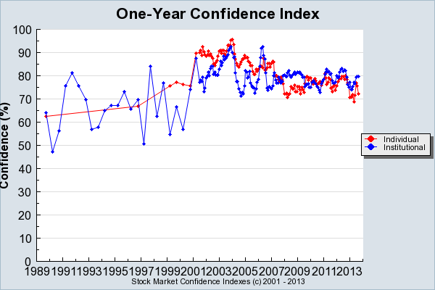

Confidence that the stock market will go up in the succeeding year rose fairly steadily over the years from 1989 to 2004, both for institutional and for individual investors. At the peak of One-Year Confidence, as of December 2003, 92.52% of institutional investors expected the market to go up over the succeeding year, and as of January 2004 95.62% of individual investors thought the same. After that, there was a brief moment of high confidence among institutional investors in 2006. Individual investor confidence bottomed in April 2008, just before the subprime crisis, and, surprisingly, improved with as the crisis worsened.

<http://som.yale.edu/faculty-research/our-centers-initiatives/international-center-finance/data/stock-market-confidence-indices/stock-market-confidence-indices>

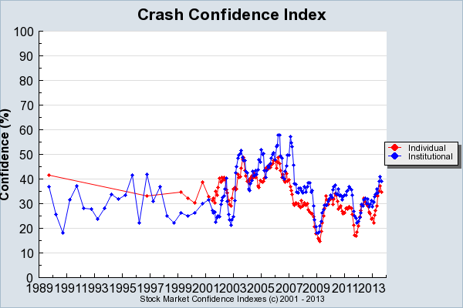

Confidence that there will be no stock market crash in the succeeding six months generally declined (though with a lot of ups and downs) over the years since 1989 until the stock market bottomed out in late 2002. Just after the terrorist attacks of September 11, 2001, Crash Confidence actually rose a little. But Crash Confidence reached its lowest point at 20.79% for institutional investors and 28.95% for individual investors as of November 2002. Crash confidence reached its all-time low, both for individual and institutional investors, in early 2009, just months after the Lehman crisis, reflecting the turmoil in the credit markets and the strong depression fears generated by that event, and is plausibly related to the very low stock market valua http://som.yale.edu/faculty-research/our-centers-initiatives/international-center-finance/data/stock-market-confidence-indices/stock-market-confidence-indicestions then. The recovery of crash confidence starting in 2009 mirrors the strong recovery in the stock market.

<http://som.yale.edu/faculty-research/our-centers-initiatives/international-center-finance/data/stock-market-confidence-indices/stock-market-confidence-indices>

## Developments in Sentiment Based Decision Making

### Role of Arbitrage

Donald MacKenzie (2003). Long-Term Capital Management and the sociology of arbitrage. *Economy and Society* Volume 32 Number 3 August 2003: 349–380

Arbitrage is a key process in the practice of financial markets and in their theoretical depiction: it allows markets to be posited as efficient without all investors being assumed to be rational. This article explores the sociology of arbitrage by means of an examination of the arbitrageurs, Long-Term Capital Management (LTCM). LTCM’s 1998 crisis is analysed using both qualitative, interview-based data and quantitative examination of price movements. It is suggested that the roots of the crisis lay in an unstable pattern of imitation that had developed in the markets within which LTCM operated. As the resulting ‘superportfolio’ began to unravel, arbitrageurs other than LTCM fled the market, even as arbitrage opportunities became more attractive, causing huge price movements against LTCM. Three features of the sociology of arbitrage are discussed: its conduct by people often personally known to each other; the possibility and consequences of imitation; and the limits on the capacity of arbitrage to close price discrepancies. It is suggested that by 1998 imitative arbitrage formed a ‘global microstructure’ in the sense of Knorr Cetina and Bruegger.

### Market Movements and Sentiment

Paul C. Tetlock. (2007). Giving Content to Investor Sentiment: The Role of Media in the Stock Market. *Journal of Finance.* Vol 62 (3), pp 349-38.

I quantitatively measure the interactions between the media and the stock market using daily content from a popular*Wall Street Journal* column. I find that high media pessimism predicts downward pressure on market prices followed by a reversion to fundamentals, and unusually high or low pessimism predicts high market trading volume. These and similar results are consistent with theoretical models of noise and liquidity traders, and are inconsistent with theories of media content as a proxy for new information about fundamental asset values, as a proxy for market volatility, or as a sideshow with no relationship to asset markets.

### News Flow

Timely measurement of the state of the macroeconomy relies traditionally on low-frequency observations of a few economic aggregates that refer to previous weeks, months, or even quarters. A prominent example is the advance estimate of GDP released quarterly about a month after the end of the quarter. The low frequency and delayed observation of any such economic aggregate considered in isolation stands in sharp contrast with the rich economic news ow that market participants observe daily. This news ow contains information that agents use to learn about the economy in the absence of private information. In particular, the macroeconomic news literature has identi_ed a large cross-section of dozens of di_erent news releases that have signi_cant and immediate e_ects on _nancial markets (e.g., Andersen et al., 2003).

Alessandro Bebery, Michael W. Brandtz, Maurizio Luisi (2013). Distilling the Macroeconomic News Flow. (University of Pennsylvania)

Andersen, Torben G., Tim Bollerslev, Francis X. Diebold, and Clara Vega, 2003, Micro economic effects of macro announcements: Real-time price discovery in foreign exchange, *American Economic Review* Vol 93, pp 38-62.